**Question:**

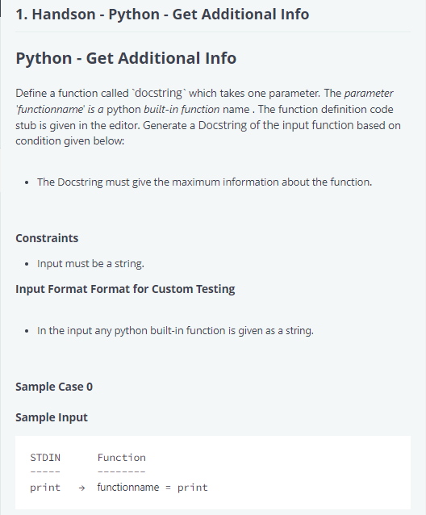

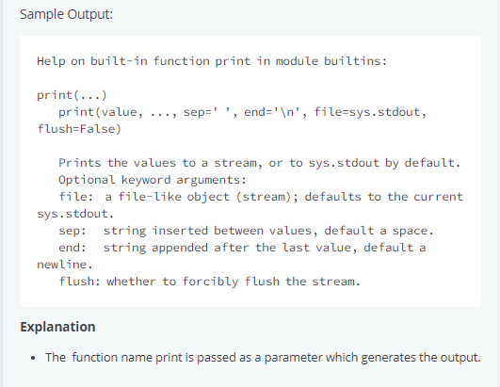

**Answer:**

import math

import os

import random

import re

import sys

# Complete the 'docstring' function below.

#

# The function is expected to output a STRING.

# The function accepts STRING x as parameter.

def docstring(functionname):

    # Write your code here

    help(functionname)

if __name__ == '__main__':

    x = input()

    docstring(x)

**Explanation:**

In Python, the help() function is a built-in function that provides information about modules, classes, functions, and modules.

In this article, we will learn about help function in [Python](https://www.geeksforgeeks.org/python-programming-language/).

**help() function in Python Syntax**

***Syntax****: help([object])*

***Parameters (Optional) :****Any object for which we want some help or the information.*

If the help function is passed without an argument, then the interactive help utility starts up on the console.

**What is Help function in Python?**

The Python help function is used to display the documentation of modules, functions, classes, keywords, etc. It provides information about modules, classes, functions, and methods. It is a useful tool for getting documentation and assistance on various aspects of Python.

**More Details:**

[**Help function- GeeksForGeeks**](https://www.geeksforgeeks.org/help-function-in-python/)